Dear Investigator,
I’m so glad you’re interested in joining the Bell Neuroendocrinology lab at DePaul! Here’s a bit more information.
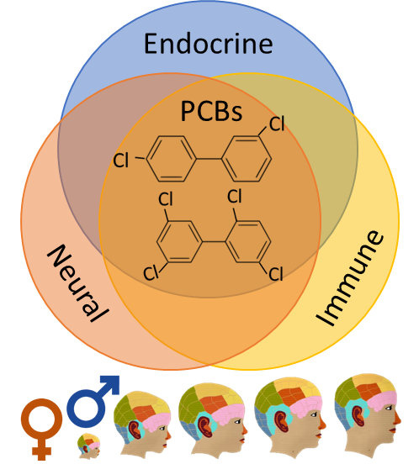
Goals: The big-picture goal of the lab is to understand the effects of environmental stressors on the developing brain and body.
Narrowing that down a bit, we’re currently focused on environmental contaminants, and within that, endocrine disrupting chemicals (EDCs). EDCs are known to alter normal functions of hormones that regulate reproduction, stress responses, and growth/metabolism. We’re exploring the possibility that EDCs exert these effects by disrupting neural and immune systems, in concert with the endocrine changes. We’re particularly interested in the developing brain because disruptions during neonatal and adolescent development can have long-lasting effects on later health and behavior. We’re also interested in sex differences; male and females respond to these chemicals differently because some aspects of development of male and female bodies (including brain and behavior) are initially determined by circulating hormones. This work has potential relevance to understanding mental health and neurodegenerative disorders associated with environmental contamination, however our focus is currently basic research in an animal model.

Techniques: We use polychlorinated biphenyls (PCBs) as a model EDC and study their effects in a rat model. We quantify alterations in:
- developmental outcomes by weighing / observing the animals; requires being comfortable with, and respectful of, our rats.
- organ size; requires some gross anatomy knowledge and dissecting skills.
- gene expression by isolating RNA and quantifying with qPCR; requires attention to protocol detail and micropipetting skills.
- inflammatory molecules / hormones with bead assays; more attention and micropipetting
- hormone and neurotransmitter receptors and enzymes with immunohistochemistry; requires perfusing and sectioning brains, histology, neuroanatomy, and microscopy.
- behavior via tests of reward, anxiety, and social interactions.
- Isolated cellular function; requires primary culture methods, sterility, attention to detail.
Expectations of Students: In order to achieve these goals, we all must commit to:
- maintaining a clean and safe lab environment – precautions with chemicals necessary.
- being thorough and honest in data collection – even / especially with mistakes.
- using respectful and timely communication – email and/or in person is preferred.
- fulfilling responsibilities – we’ll work together to set reasonable ones.
- being engaged and enthusiastic – science is awesome (!) and lots of students are interested in getting lab experience. Take advantage of the opportunity at hand.
A couple notes:
- Science is the business of dealing with the unexpected – things don’t always go to plan, and half the fun is figuring out how to adjust.
- The workload and task we do will vary day to day, week to week, and quarter to quarter. Some days, we might be doing a time intensive or time sensitive task. On those days, it is essential that you fulfill whatever responsibility we’ve planned on! Other days, we might be in a lull. Responsibility, flexibility, and communication are key.
- Animals don’t know what a weekend or vacation is – expect unusual work days.
- In order to give you the learning experience that you deserve and ensure high quality science, there is a limit to the number of students that can join the lab. Ideally, students in the lab will range in their career progression such that more senior students can train more junior students before moving on to even bigger and better things.
- I expect that you would volunteer for a quarter to make sure that we’re a good fit. After that, paid positions (two, during the school year for up to 10 hours/week) and class credit are options, but only to those that have demonstrated solid work and have the available time.
- If you are currently in one of my classes, please note that your performance in class could influence my decision, but that it will not influence your class grade if we can’t find a space in the lab for you this year.
- We’ll want to have a conversation before both you or I commit to anything.

Still interested? Please print and provide me the following, by dropping them off at my office (McGowan N Room 122, in Bio Advising Suite) or in my mailbox (McG N Room 118).
- A cover letter that includes
  - Your contact information
  - When you expect to graduate and how long you anticipate wanting to be in the lab. Please include whether you’d be interested in working in the lab over the summers.
    - I’m looking for folks to be involved long-term, not just for a quarter or two.
  - Reasons for wanting to do research, in general
  - Reasons for wanting to do research, in this lab
  - Number of hours you would be willing to commit.
    - I require at least 8, so that you can learn enough to work independently and make a real contribution. That said, some weeks will be busier than others, so we can *sometimes* be flexible in your weekly hours.
- Current resume or curriculum vita
  - Please include any research experience/techniques and computer/software skills.
- Unofficial copy of your full college transcript
  - From DePaul and any other institution
  - I’m looking for coursework preparation (Intro Bios, some Chem) and red flags (Ds and Fs). I won’t judge you solely on your GPA
- Your class/work/mtg schedule for current and/or upcoming quarters. If specific schedules aren’t available, then please send estimates on the number of hours you’ll spend with classes, and other work or volunteer commitments.
- What times you’re free to chat in person (~ 30 minutes) in the upcoming week.

